**STAGING**

1. Login as **root** user

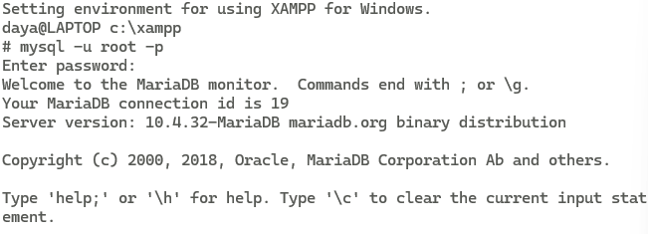

1. Check all possible privileges  
   Query:

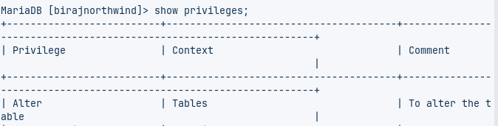

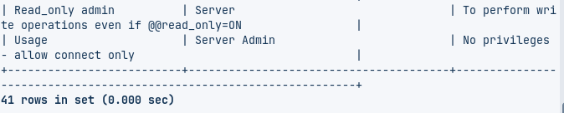

1. List Existing Users of Mysql DBMS  
   Query:  
   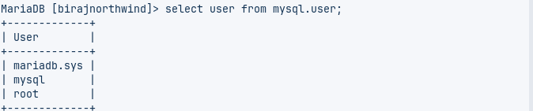
2. Check privileges of existing user as

Query: 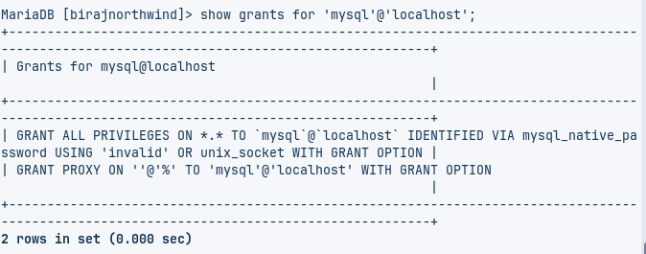

**SETUP**

1. List all existing Database: Query:  
   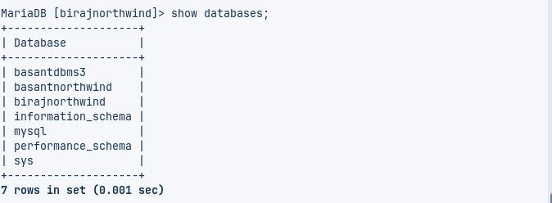
2. Create a database <your-name> i.e. biraj  
   Query:
3. Verify your database is created:

Query:

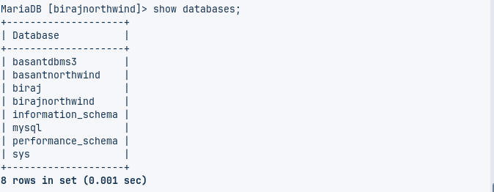

1. Create a user <your-name> i.e. basant  
   Query:  
   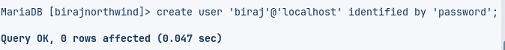
2. Exit current session  
   Query:



1. Login as newly created user i.e. <yourname>  
   Query: 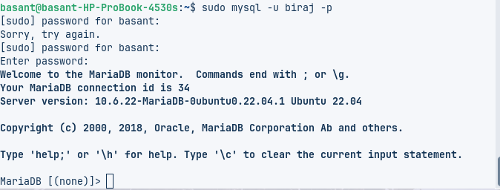
2. Check databases and exit  
   Query:  
   Query:

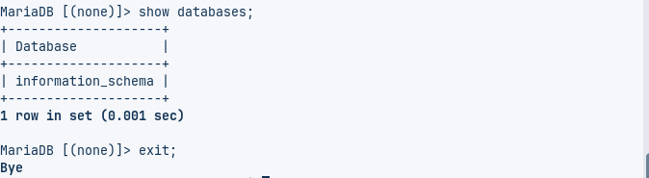

**GRANT**

1. Login as root user  
   Query:

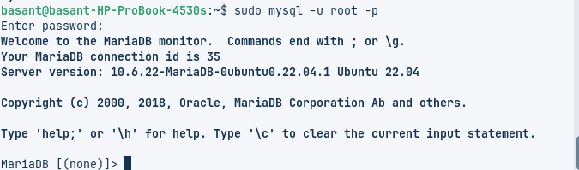

1. GRANT Privileges to user <yourname> to existing databases and exit  
   Query:  
     
   Query: 

Query:



1. Login as <yourname> user  
   Query:

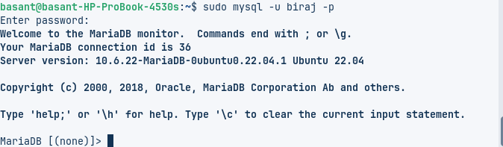

1. Use database, CREATE table tb1(id,name)  
   Query:

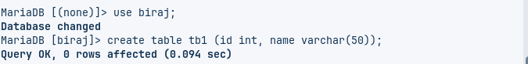

1. INSERT 2 records, UPDATE 1 record, Delete 1 RECORD

Query:  


Query:  


Query:  


1. Exit  
   Query:



**REVOKE:**

1. Login as root user

Query:

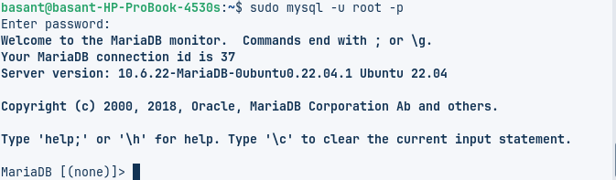

1. REVOKE Privileges to user <yourname> to existing databases and exit  
   Query:  
   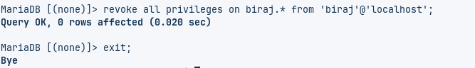
2. Login as <yourname> user

Query:

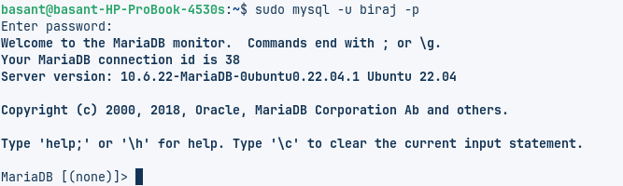

1. Check Databases

Query:

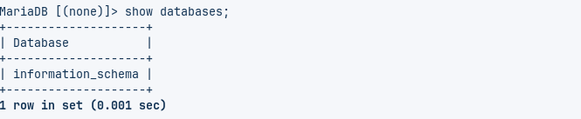

1. Exit

Query:

